Problem while logging in STEASY Software
1 .Right click on My Computer or This PC----Select Manage option there

2. Select Services and Applications or Services there

3. Select SQL Server(STEASY) there and right click on it and select Restart there

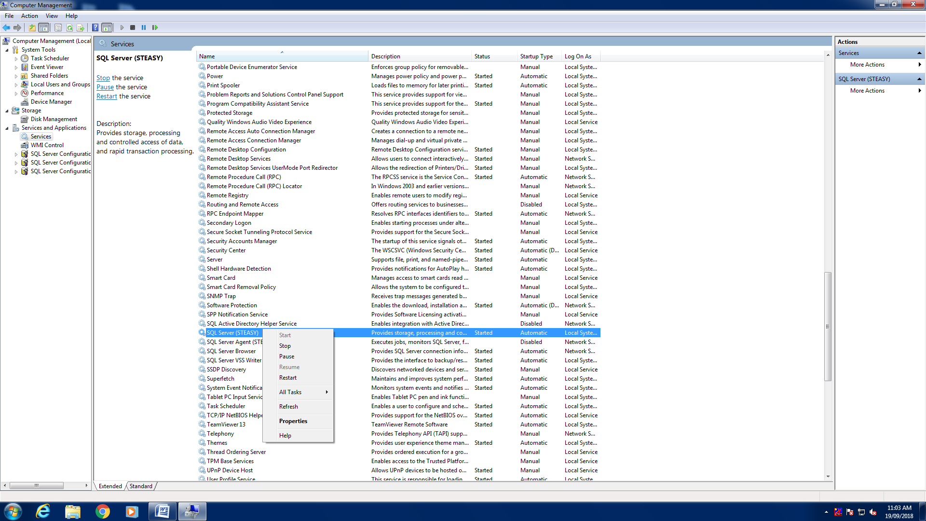

4.After Restarting it login to your STEASY Software and then its done

